1. **Installed Anaconda on the system with Python version 3.6**

Created a Tensor Flow environment in the anaconda:

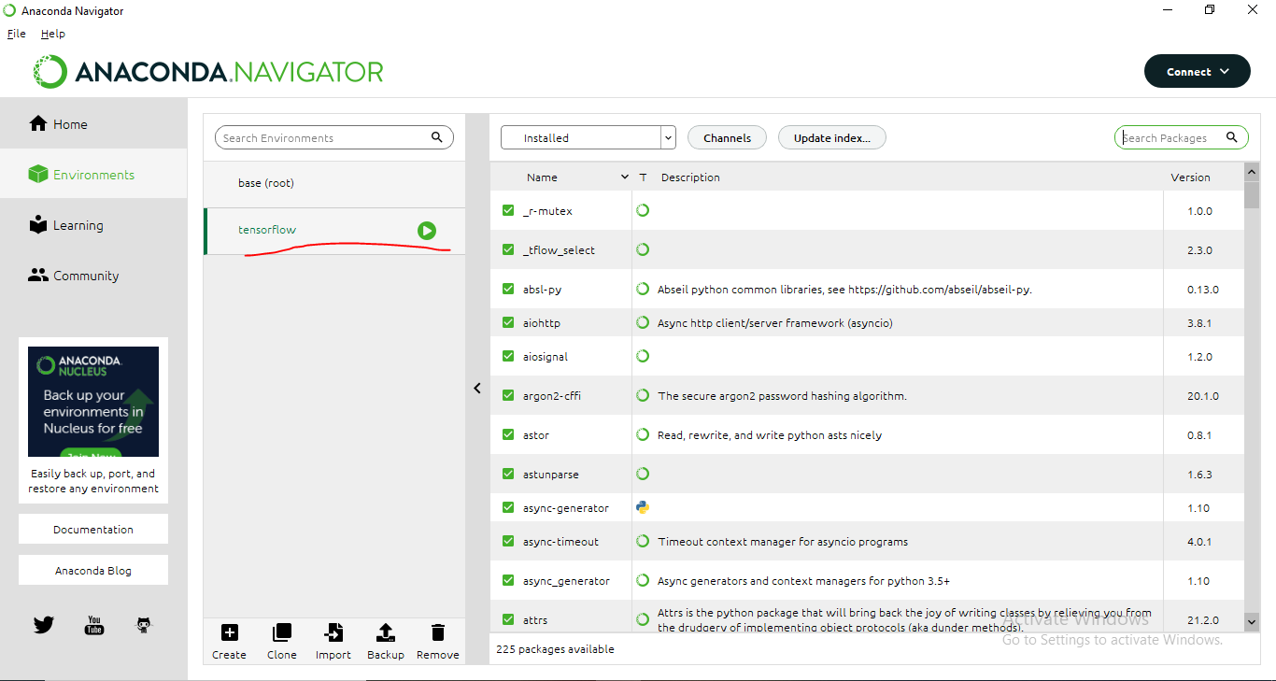

Downloaded Tensor Flow in your Tensor Flow environment:

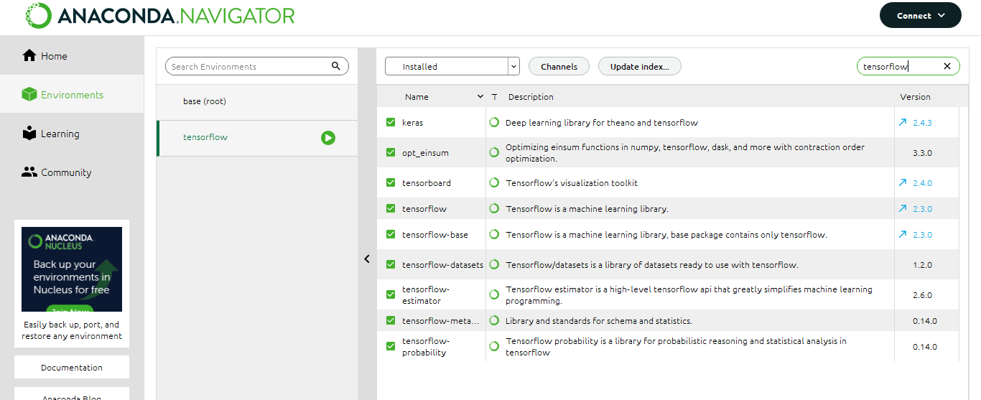

1. **Download Pandas, Numpy, SciKit-learn, Scipy and Matplotlib packages in both the environments**

* ***Base (Root)*** ***Environment***

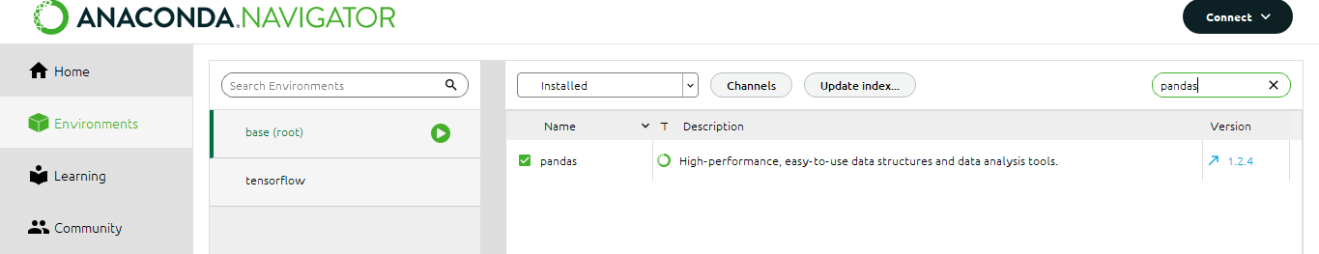

Pandas

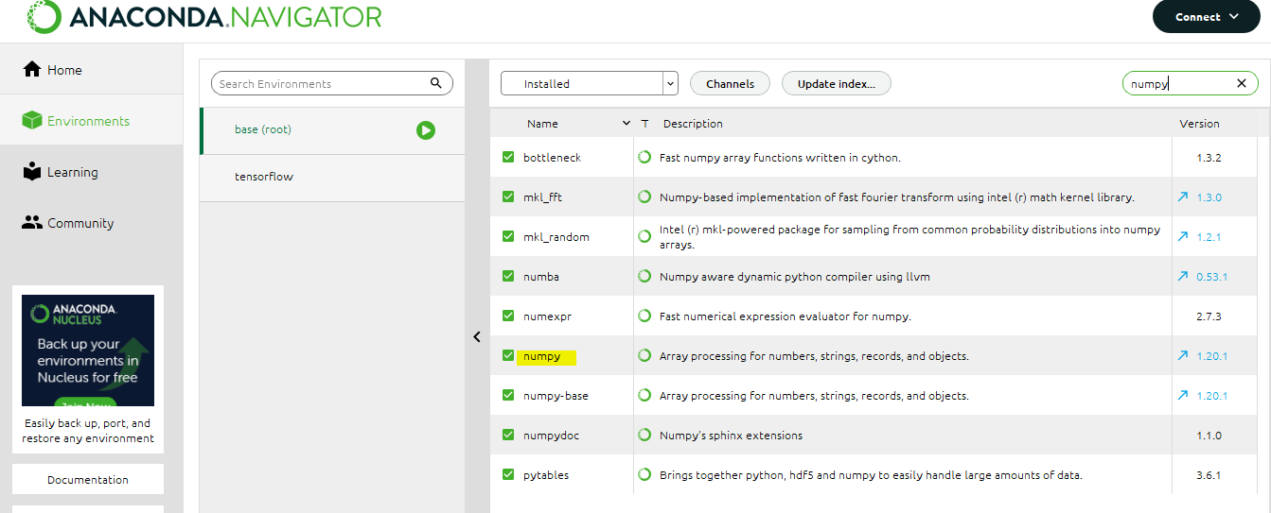

Numpy

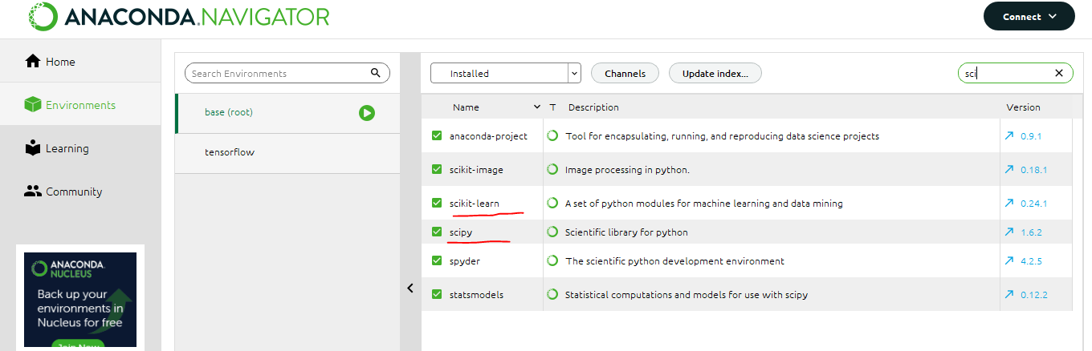

Scipy and Scikit-Learn

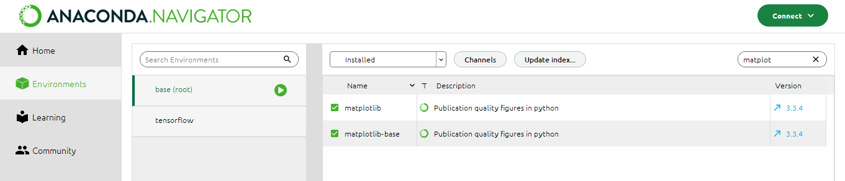

Matplotlib

* ***Tensorflow Environment***

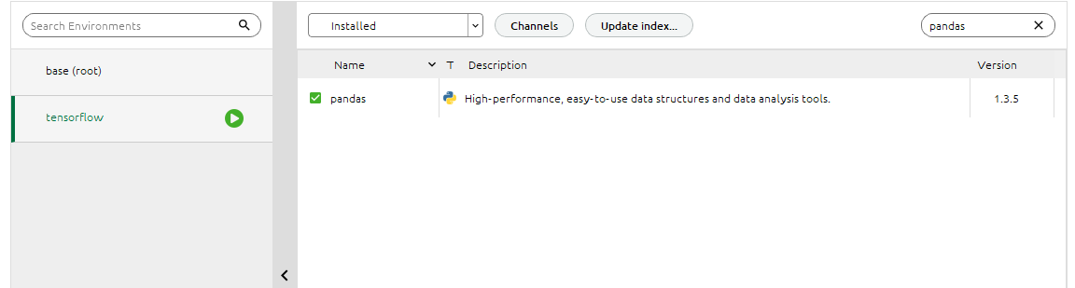

Pandas

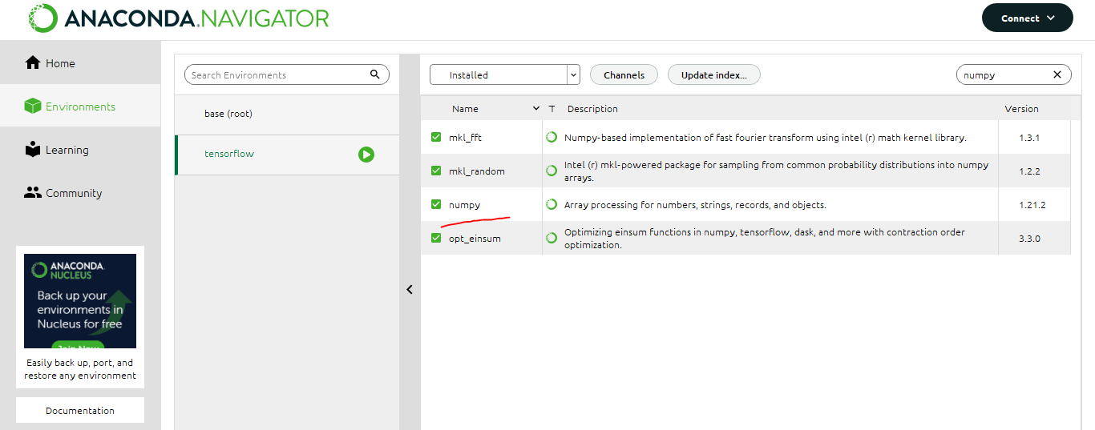

Numpy

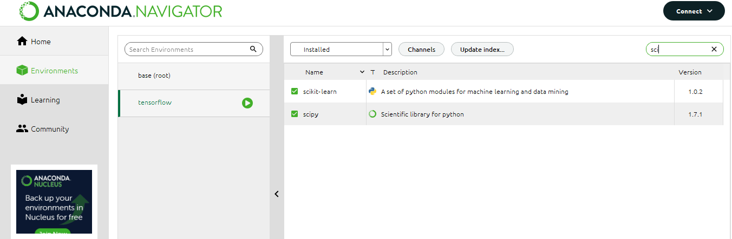

Scipy and Scikit-Learn

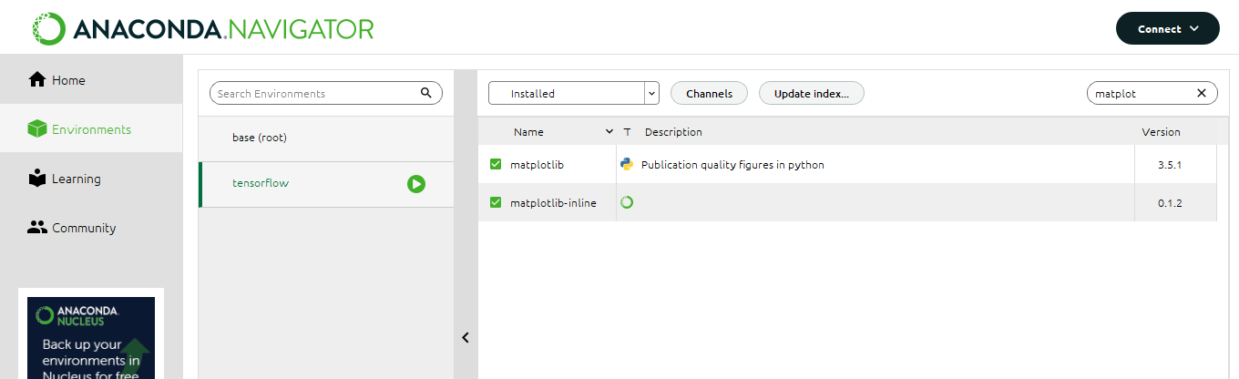

Matplotlib

1. **Install following packages only in your Tensor Flow environment**

* ***Keras***

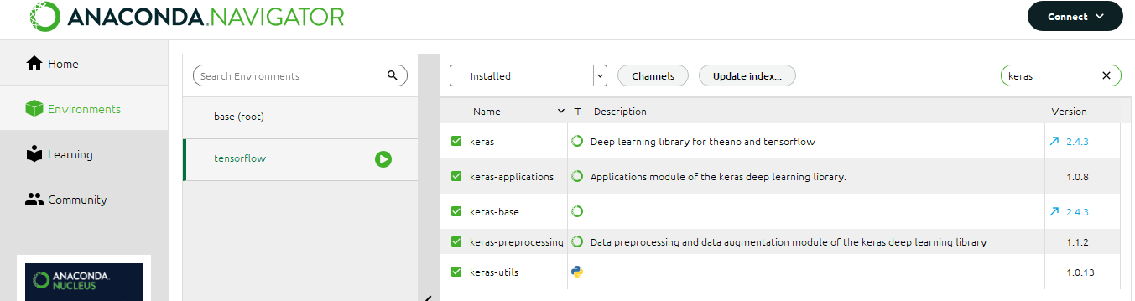

* ***TFLearn***

